CHOOSY User Manual

HOW TO OPERATE THE CHOOSY BOOKING SYSTEM

# Contents

Contents 1

What is CHOOSY? 2

Opening CHOOSY 2

Checking dates for Availability 3

Create a booking 6

Cancel a Booking 8

# What is CHOOSY?

**CHOOSY** is an easy-to-use booking system designed for the officers from the MoD Welfare department. **CHOOSY** allows the user to create and handle new bookings for accommodation in the Colchester Garrison contact houses. **CHOOSY** implements features such as the ability to send formatted emails, alter CSV files all while providing a friendly, effective user interface.

# Opening CHOOSY

Upon opening **CHOOSY** you will have view of the entire user interface that will look like this:

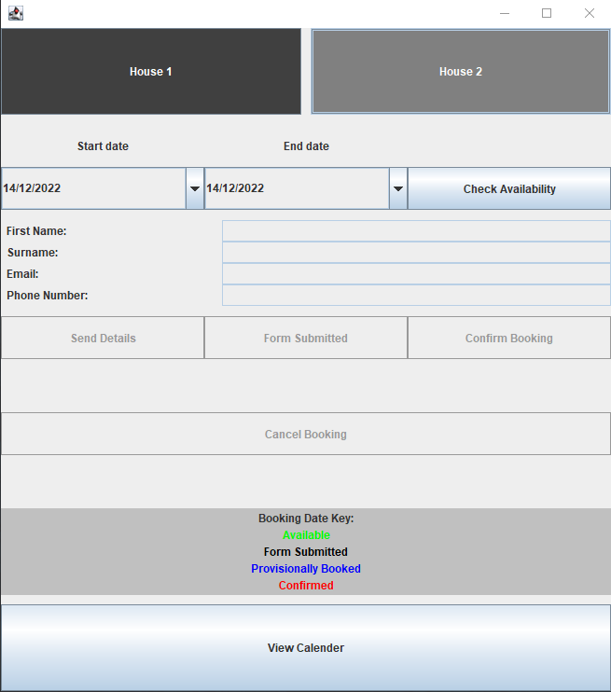

There are two buttons at the top of the application being named ‘**House 1**’ and ‘**House 2**’ respectively. These buttons are used to select the bookings and dates for each of the contact houses. By default, **House 1** will be selected.

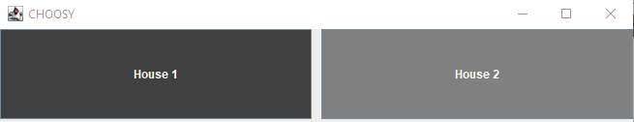

# Checking dates for Availability

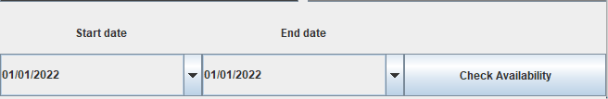Once a house is selected, you will find the ‘**Start date’** and ‘**End date’** headings which will allow you to select a range of dates that and check the availability for that range using the ‘**Check availability**’ button.

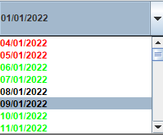

Once you select the dropdown arrow, you will find date texts in **red**, **green**, **blue** or **black**. The green text indicates the date has not yet been booked and is **available** while the red text indicates that it has already been booked and is **unavailable**. The black text means the **form has been submitted** for a booking on that date and the blue text means there is a **provisional booking** for that day.

Once a range is selected you are then able to click the **‘check availability’** button. If the dates are **available** then the text “**Booking is available**” will be displayed below, the input form will be accessible as well as the ‘**send details’** button.

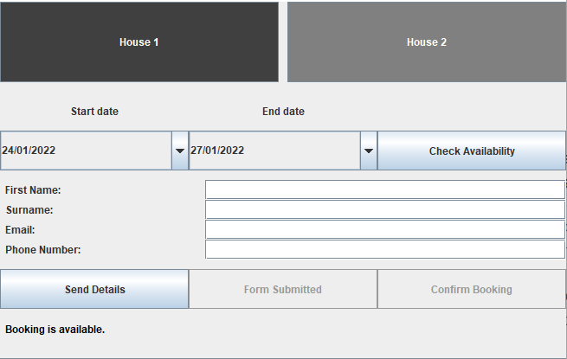

If any of the dates within the range are **unavailable** then the range will automatically change to that of the booking that causes the unavailability.

For example, if the date **20/01/2022** is **unavailable** because of another booking, that bookings details and status will be returned. See below for an example.

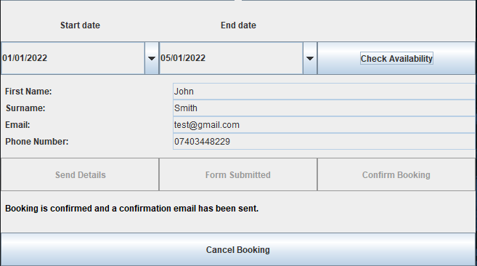

At the bottom of the application you can find the booking date key and a ‘**View Calendar’** button.

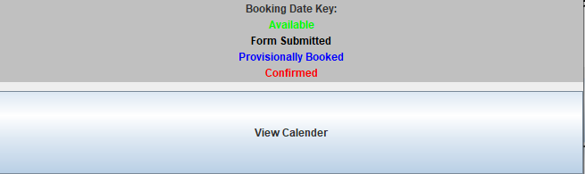

If you press the button you may also see the availability in a calendar format for convenience. If you would like to return to booking sheet, simply press the **‘Booking sheet**’ button above the calendar.

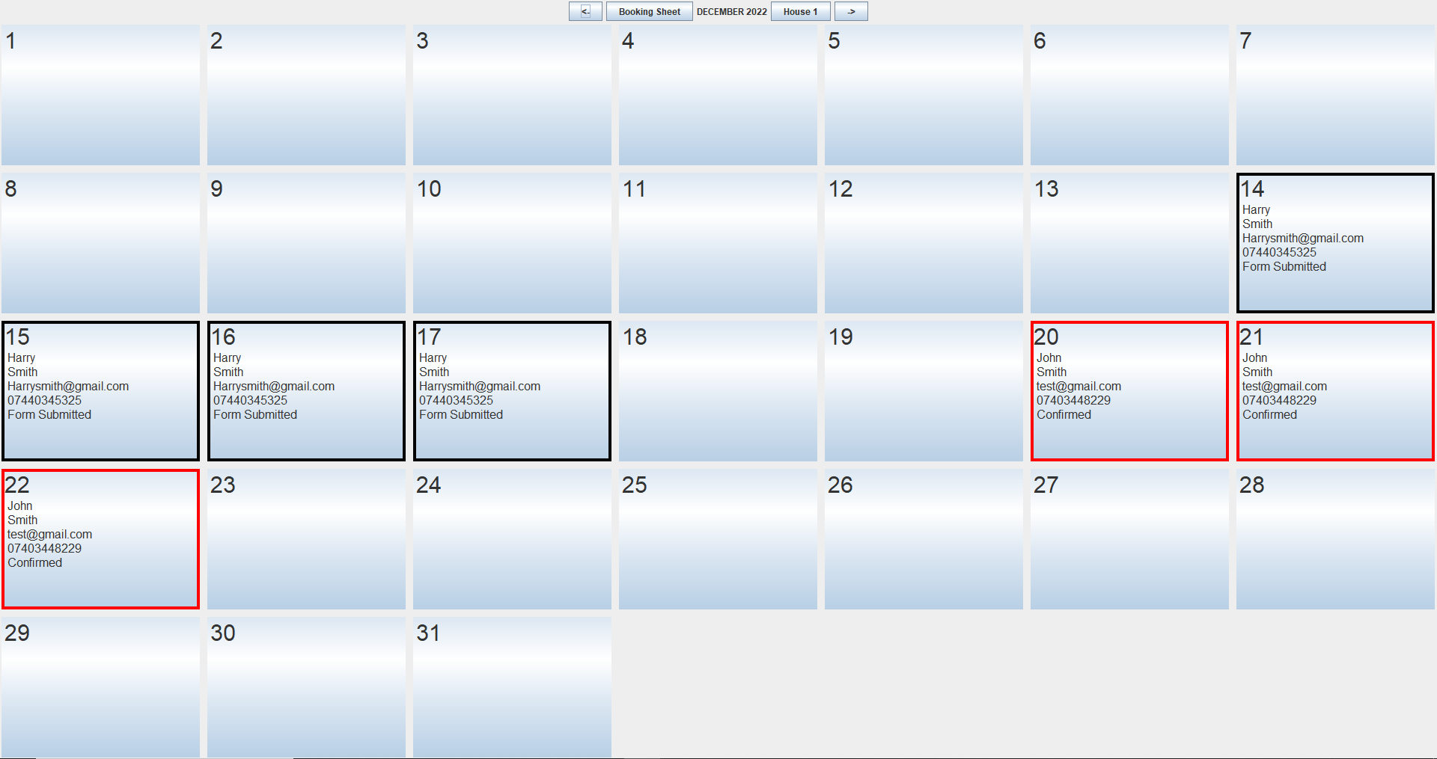

# Create a booking

If you would like to create a booking, head to the booking sheet and select the house/date range and check for availability. If **Available** then you will then need to input the details for the booking. These include: **First name**, **Surname**, **Email** and **Phone number**. Once you fill out the details you may press the **‘Send details’** Button. This will send an email to the email specified with a link to a google form where the recipient may fill out more details and confirm the booking. The dates will also be **provisionally booked** within CHOOSY.

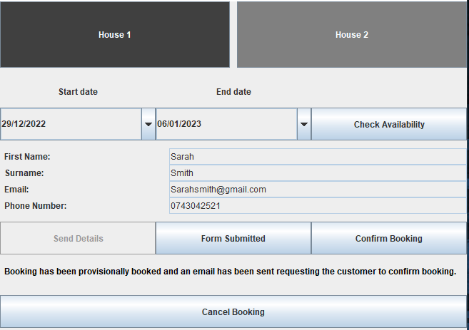

Once the recipient has completed the google form, you may press the **‘Form Submitted’** button. The status of the booking will be changed accordingly.

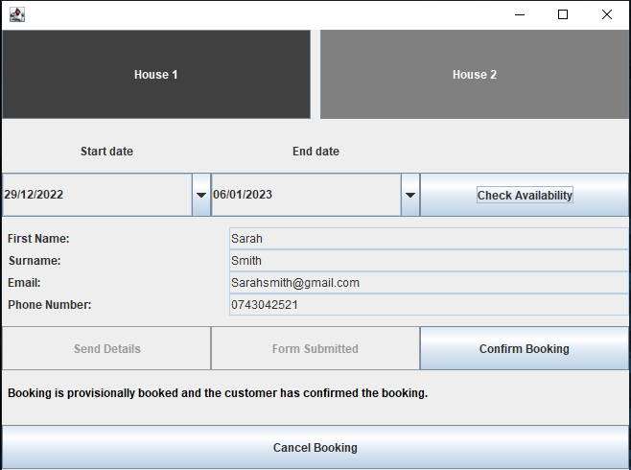

Now that the recipient has confirmed the dates and filled out the form, they must send payment for the booking. Once the payment is received then you may press the ‘**Confirm Booking**’ button. This will change the status to **‘Booked**’ and the customer will receive another email to confirm the booking.

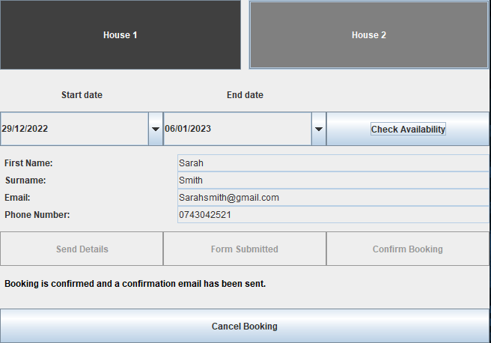

# Cancel a Booking

If you would like to **cancel** a booking for any purpose then simply return the booking on the booking sheet by ‘**Checking Availability**’ for any date within the specified booking. Once the booking is displayed, simply press the ‘**Cancel Booking**’ at the bottom of the interface. This will remove the booking entirely from the application and will send the customer an email with the cancellation confirmation.

